**TABLE OF CONTENT**

|  |  |  |
| --- | --- | --- |
| **CHAPTER NO** | **TITLE** | **PAGE NO** |
|  | ABSTRACT  LIST OF FIGURES  LIST OF SYMBOLS,ABBREVATIONS  AND NOMENCLATURE | 2  3  4 |
| 1 | INTRODUCTION  1.1 DOMAIN INTRODUCTION  1.2 SYSTEM INTRODUCTION  1.3 GENERAL FEATURES  1.4 APPLICATION | 5  6  6  7  9 |
| 2 | EXISTING WORK  2.1EXSTING SYSTEM  2.2DISADVANTAGES | 10  10  11 |
| 3 | PROPOSED WORK  3.1OBJECTIVES  3.2PROPOSED SYSTEM  3.3SYSTEM DESIGN & FEATURES  3.4MODULES & ITS FUNCTIONALITY  3.5ADVANTAGES | 12  12  12  14  24  25 |
| 4 | CONCLUSION  4.1FUTURE WORK | 27  27 |
| 5 | REFERENCES | 35 |

**ABSTRACT**

* The title of Our Project is Student Information System.
* Student Information Management System can be used by education institutes to maintain the records of students easily.
* Achieving this objective is difficult using a manual system as the information is scattered, can be redundant and collecting relevant information may be very time consuming.
* All these problems are solved using this project.

|  |  |  |
| --- | --- | --- |
| **NO** | **LIST OF FIGURES** | **PAGE** |
| 3.3.1 | USE CASE DIAGRAM | 14 |
| 3.3.2 | CLASS DIAGRAM | 15 |
| 3.3.3 | SEQUENCE DIAGRAM | 16 |
| 3.3.4 | ACTIVITY DIAGRAM | 17 |
| 3.3.5 | COMPONENT DIAGRAM | 18 |
| 3.3.6 | DEPLOYMENT DIAGRAM | 19 |
| 3.3.7 | COLLABORATION DIAGRAM | 20 |
| 3.3.8 | STATE CHART DIAGRAM | 21 |

**LIST OF SYMBOLS ABBREVATIONS AND NOMENCLATURE:**

1.PHP:HYPERTEXT PREPROCESSOR

2.SQL:STRUCTURED QUERY LANGUAGE

3.HTML:HYPERTEXT MARKUP LANGUAGE

**CHAPTER 1**

**INTRODUCTION**

* A student information system (SIS) is a management information system for education sector establishments used to manage student data.
* It integrates students, parents, teachers and the administration.
* Student information systems provide capabilities for registering students in courses, documenting grading, transcripts of academic achievement and co-curricular activities, and the results of student assessment scores
* It is also helpful in forming student schedules, tracking student attendance,generating reports and managing other student-related data needs in an educational institution.
* As all this data storage and handling is cloud-based, so it is super secure. Setup is often easier, access is wider, technical support is immediate, and adaptations to changes is more easily possible

**Objectives:**

Online registration of student

Maintenance of student records

Searching student records

**1.1 DOMAIN INTRODUCTION**

* Student Information system will store all the details of the students including their background information educational qualifications, personal details and all the information related to their resume
* Without a Student information System, managing and maintaining the details of the student is a tedious job for any organization

**1.2 SYSTEM INTRODUCTION**

**Operating Systems:** Microsoft Windows

**Hardware Configuration:**

* HARD DISK: 80 GB or Higher RAM 4GB or Higher
* Pentium IV Processor
* Network Connectivity

**Software Configuration:**

* OPERATING SYSTEM WINDOWS10
* FRONT END PHP with bootstrap

* BACK END MYSQL
* TOOLS XAMPP(cross-platform apache,Mysql )

**Technologies Used**

Front End: HTML and Javascript

Web designing language PHP

RDBMS(Back end) MySQL

**1.3 GENERAL FEATURES**

**There are three different users who will be using this product:**

* Administrator who can view and edit the details of any students
* Students who can view their details as well as they can edit their details
* Faculty who can view and edit the details of students

**The features that are available to the Administrator are:**

* An Administrator can login into the system and perform any of the available operations.
* Can enable/disable student
* Can edit student information to the database
* Can make search for a specific student
* Can access all the details of the student.

**The features that are available to the student are**

* Student can login into the system and can perform any of the available options
* Can view his/her personal details
* Can edit his/her personal details
* Can upload his/her resume.
* Can upload his/her image.

**The features that are available to the faculty are:-**

* Can submit attendance of the students.
* Can upload his/her image
* Can Submit students exam or Test marks.
* Can Approve their leave application

**1.4 APPLICATION**

* Improved Management of Student Enrollment
* Easier Integration of Administrators, Teachers, and Parents
* Efficient Management of Student-Related Activities Efficient

Management of Student-Related Activities

* Easier Integration of Administrators, Teachers, and Parents

**1.4.1 CONSTRAINTS**

* Every user must be comfortable using computer
* All operations are in English so user must have basic knowledge of

English

**CHAPTER 2**

**EXISTING WORK (SYSTEM ANALYSIS)**

**2.1 EXSTING SYSTEM**

* System Analysis is a detailed study of the various operations performed by a system and their relationships within and outside of the system
* During analysis, data collected on the various files, decision points and transactions
* handled by the present system The commonly used tools in the system are Data Flow Diagram, interviews, etcTraining, experience and common sense are required for collection of relevant information needed to develop the system.

**System analysis can be categorized into five parts**

* + System planning and initial investigation
  + Information Gathering
  + Applying analysis tools for structured analysis.
  + Feasibility study
  + Cost/Benefit analysis.

**2.2 DISADVANTAGES**

* In the current system we need to keep a number of records related to the student and want to enter the details of the student and the marks manually.
* In this system only the teacher or the school authority views the mark of the student and they want to enter the details of the student.
* This is time consuming and has much cost

**CHAPTER 3**

**PROPOSED WORK**

**3.1 OBJECTIVES**

* Proposal of "STUDENT INFORMATION SYSTEM" for replacing the manual work of the administration

**3.2 PROPOSED SYSTEMS**

* We have successfully proposed the "STUDENT INFORMATION SYSTEM" for replacing the manual work of the administration.
* In our proposed system we have the provision for adding the details of the students by themselves So,the overhead of the school authorities and the teachers is become less
* Another advantage of the system is that it is very easy to edit the details of the student and delete a student when it found unnecessary.
* The Marks of the student are added in the database and so students can also view the details whenever they want.

**Our proposed system has several advantages**

* User friendly interface
* Fast access to database
* Less error
* More Storage Capacity
* Search facility
* Look and Feel Environment
* Quick transaction

All the manual difficulties in managing the student details in a school or college

have been rectified by implementing computerization.

**3.3 SYSTEM DESIGN AND FEATURES**

The entire system design and features are explained along with respective UML Diagrams.

**3.3.1 USE CASE DIAGRAM**

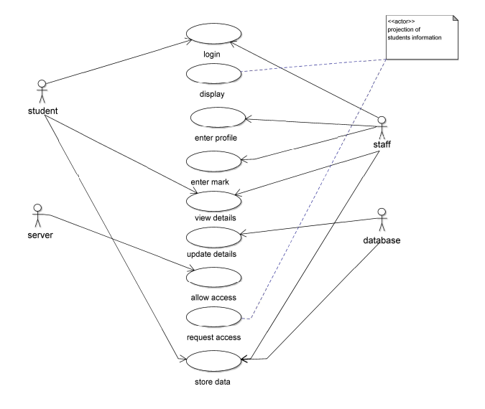

**3.3.2 CLASS DIAGRAM:**

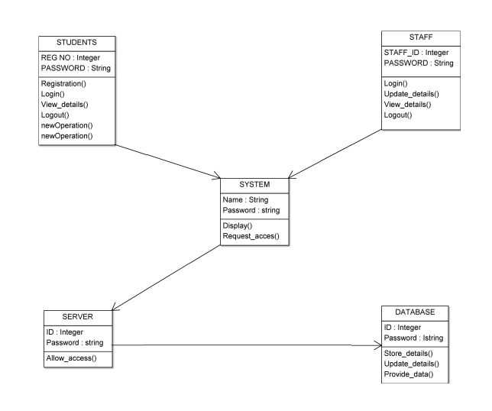

**3.3.3 SEQUENCE DIAGRAM:**

VIEW DETAILS

LOGOUT

LOGIN()

DISPLAY

LOGIN

DISPLAY

ENTER PROFILE

ENTER MARK

LOGOUT

REQUEST ACCESS

REQUEST ACCESS

ALLOW ACCESS

ALLOW ACCESS

STORE DATA

PROVIDE DATA

update

STUDENT

STAFF

SYSTEM

SERVER

DBA

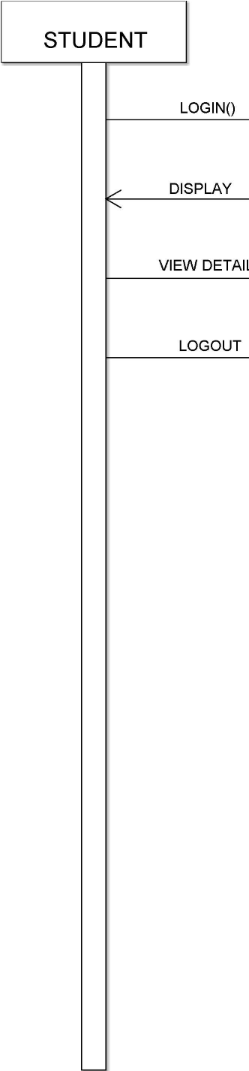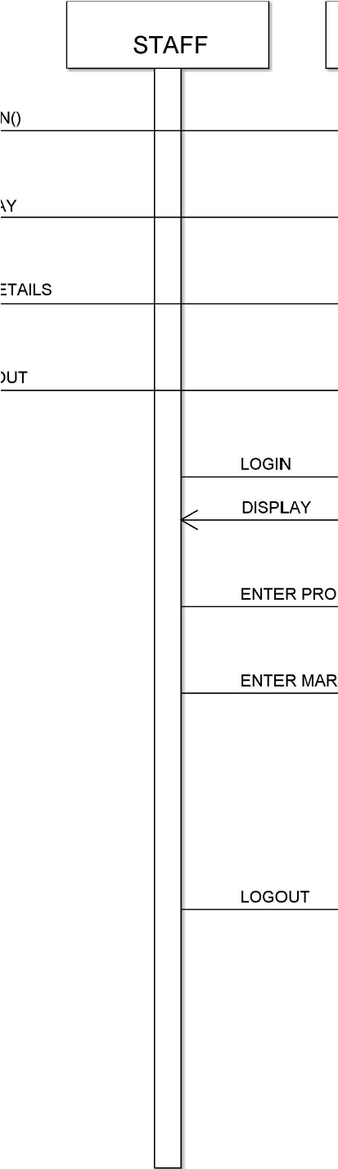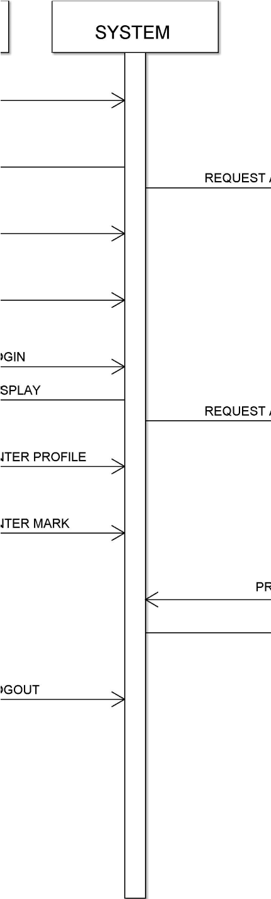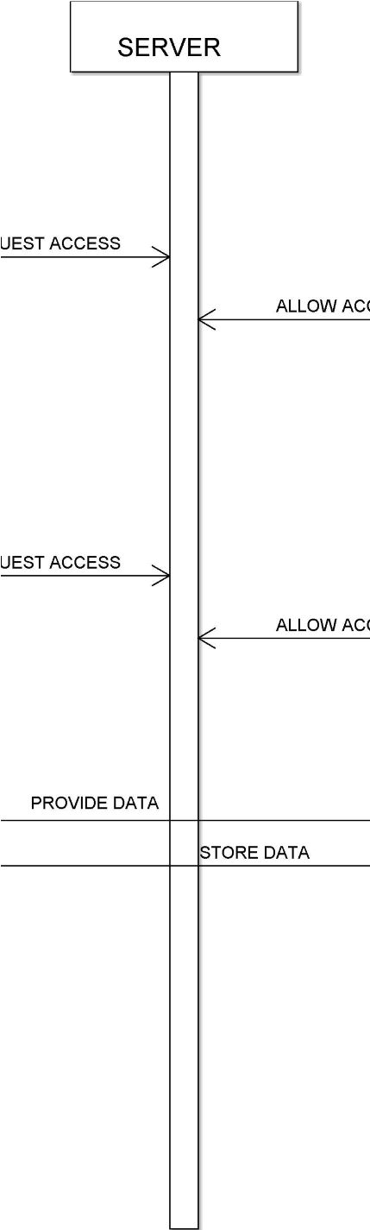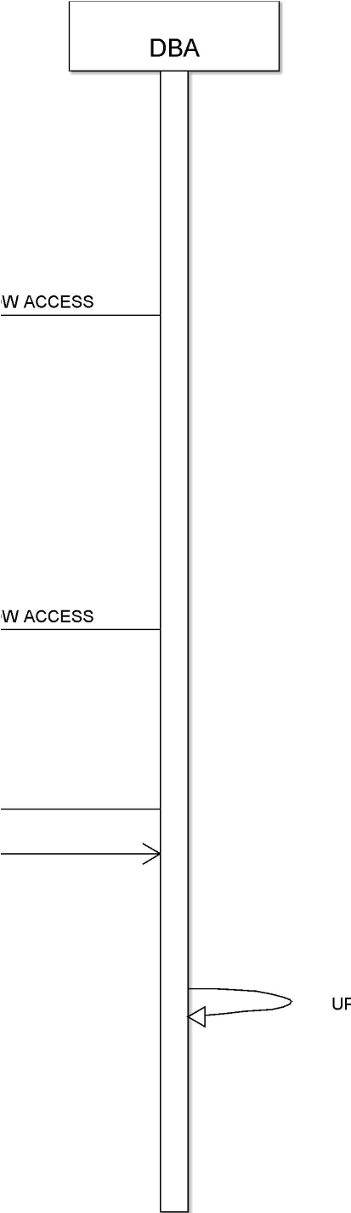

**3.3.4 ACTIVITY DIAGRAM**

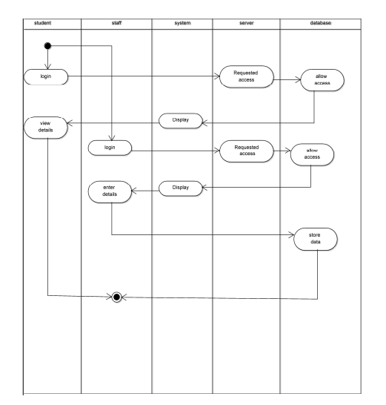

**3.3.5 COMPONENT DIAGRAM**

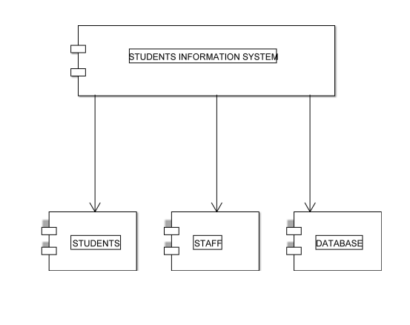

**3.3.6 DEPLOYMENT DIAGRAM**

Student

Student Management

System

Staff

DBA

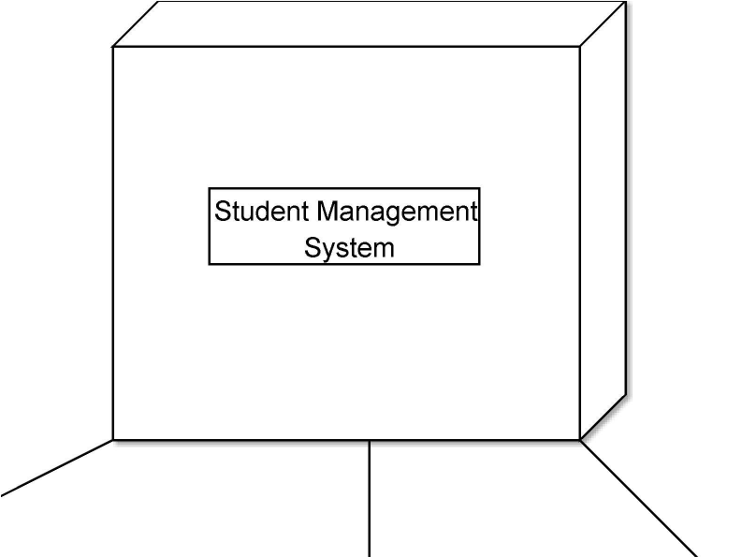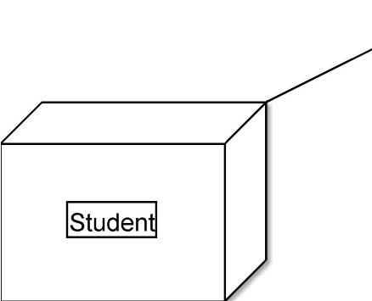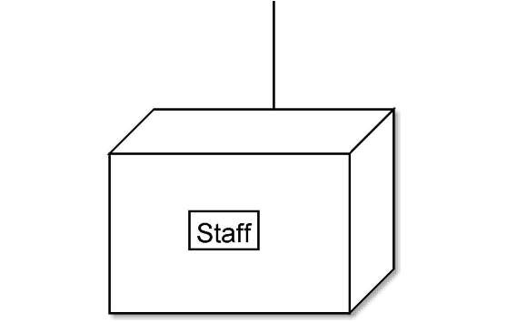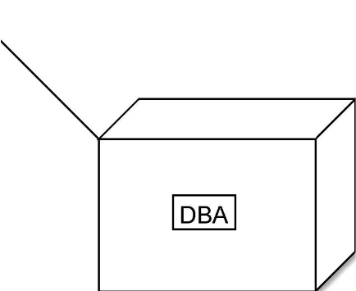

**3.3.7 COLLOBORATION DIAGRAM**

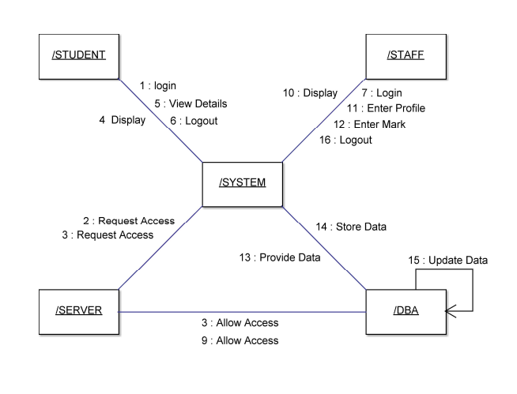

**3.3.8 STATE CHART DIAGRAM**

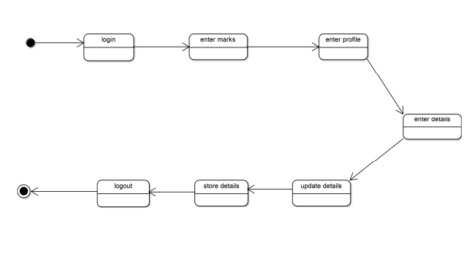

**3.3.9 FUNCTIONAL AND NON FUNCTIONAL**

**REQUIREMENTS**

**Functional Requirements:**

* The Administrator will be given more powers (enable/disable/ update) than other users.
* It will be ensured that the information entered is of the
* correct format.
* In case if incorrect form of information is added, the user
* will be asked to fill the information again
* The system can be accessed anytime

**Non-Functional Requirement:**

**Performance Requirements:** The proposed system that we are going to develop will be used as the Chief performance system for providing help to the organization in managing the whole database of the student studying in the organisation Therefore, it is expected that the database would perform functionally all the requirements that are specified

**Safety Requirements:**The database may get crashed at any certain time due to virus or operating system failure. Therefore, it is required to take the database backup.

**Security Requirements:**

We are going to develop a secured database. There are different categories of users namely Administrator,Student who will be viewing either all or some specific information form the database. Depending upon the category of user the access rights are decided. It means if the user is an administrator then he can be able to modify the data, append etc. All other users only have the rights to retrieve the information about database.

**3.4 MODULES AND ITS FUNCTIONALITY**

There are mainly 3 modules in this software

* Administrator Module
* Faculty Module
* Student Module.

**3.4.1 Admin Module:**

This is the first and the base module of the project by this module a admin is provided 10 the project to manage the faculty and student module

**3.4.2 Faculty Module:**

This module is for the faculty members of the institute all faculty are get a unique token no and a pin for registration by the administrator of the institute by using the registration id and pin the faculty will get registration page after filling that form the faculty will get registered in the institute database and they choose a password for login to their profile

**3.4.3 Student Module:**

As like faculty registration same the student will get a roll no and a pin to registered themselves. After enter the roll no and pin students are redirect to the registration page after submitting their general details student will get a roll no and a password to login their profile.

**3.5 ADVANTAGES**

Our proposed system has several advantages

* User friendly interface Fast access to database
* Less enors
* More Storage Capacity
* Search facility
* Look and Feel Environment
* Quick transaction

**3.5.1 Feasibility Analysis:**

* Whatever we think need not be feasible
* It is wise to think about the feasibility of any problem we undertake
* Feasibility is the study of impact, which happens in the organization by the development of a system.
* The impact can be either positive or negative.
* When the positives nominate the negatives, then the system is considered feasible. Here the feasibility study can be performed in two ways such as technical
* feasibility and Economical Feasibility

**Technical Feasibility:**

* We can strongly says that it is technically feasible, since there will not be much difficulty in getting required resources for the development and maintaining the system as well
* All the resources needed for the development of the software as well as the maintenance of the same is available in the organization here we are utilizing the resources which are available already

**Economical Feasibility:**

* Development of this application is highly economically feasible. The organization needed not spend much money for the development of the system already available
* The only thing is to be done is making an environment for the development with an effective supervision.
* If we are doing so, we can attain the maximum usability of the corresponding resources Even after the development, the organization will not be in condition to invest more in the organization.
* Therefore, the system is economically feasible

**CHAPTER 4**

**CONCLUSION**

* This project was carried out in a sequential manner to design and

implement the "STUDENT INFORMATION SYSTEM".

* Thus the outcome of the project is efficient
* Student Information System caters the varied requirements of the user to perform the functionality with ease and efficiency

**4.1 FUTURE WORK**

* The Student Information System(SIMS) can be enhanced to include some other functionality like marks attendance management
* Talent management of students based on their performance evaluation can be added.
* Social networking can also be added wherein students can interact with each other.
* Online class functionality can be added.
* Can evolve as an online institution
* Functionality of chat and messages can be added. • Online exam functionality can be added

**APPENDIX 1**

**SCREEN SHOTS**

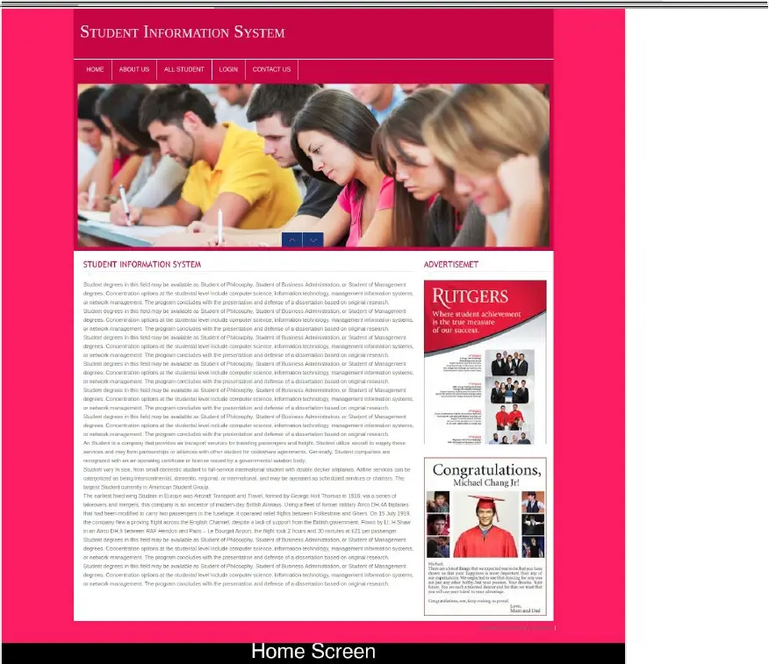

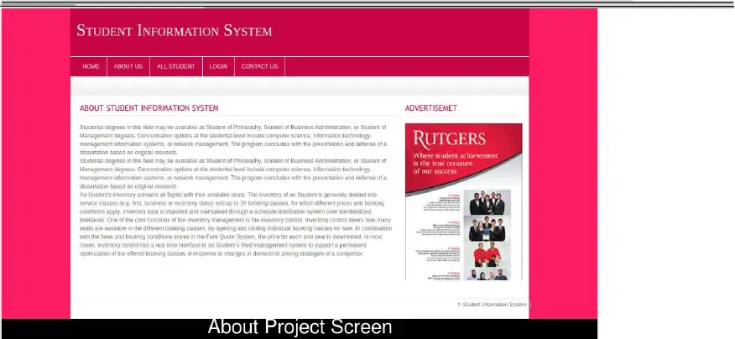

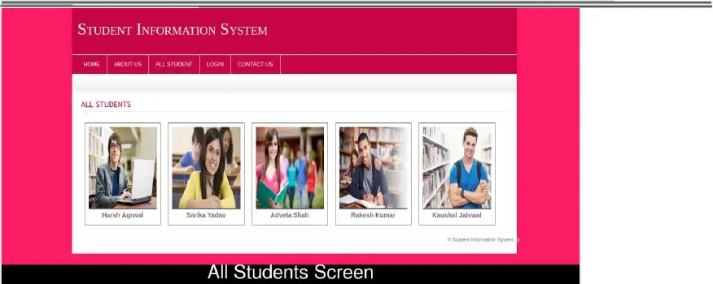

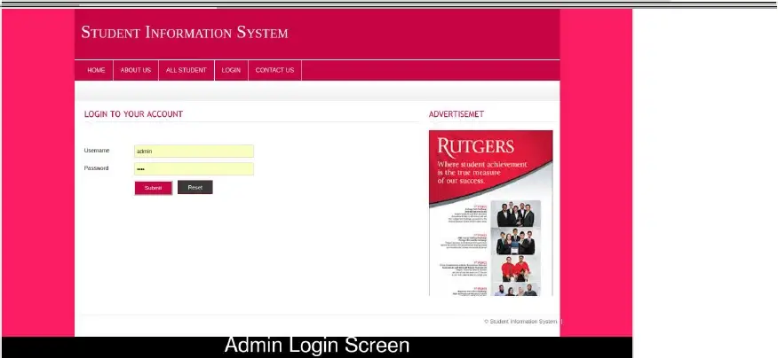

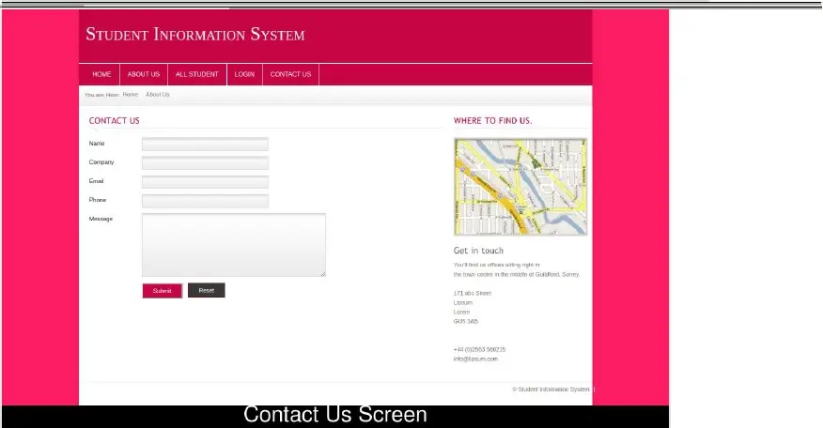

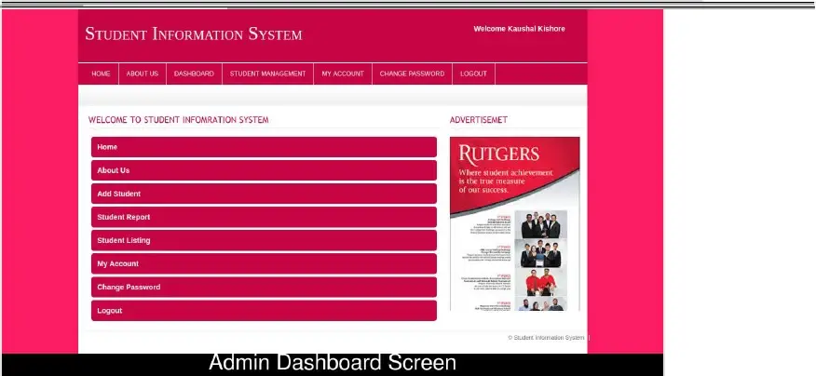

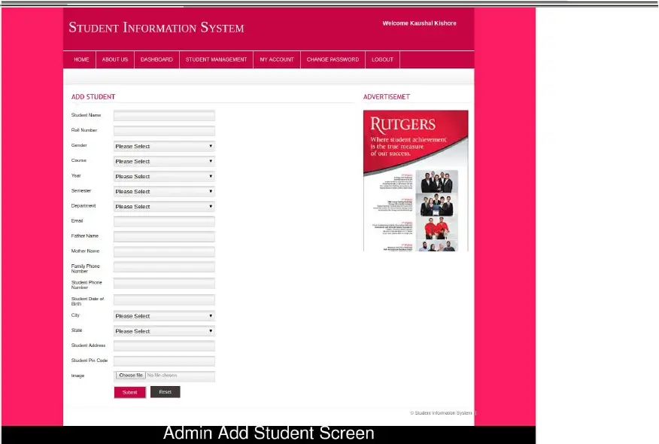

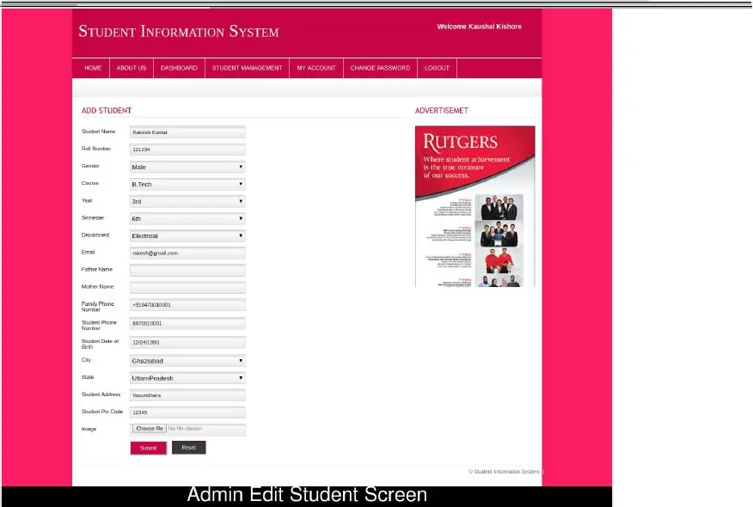

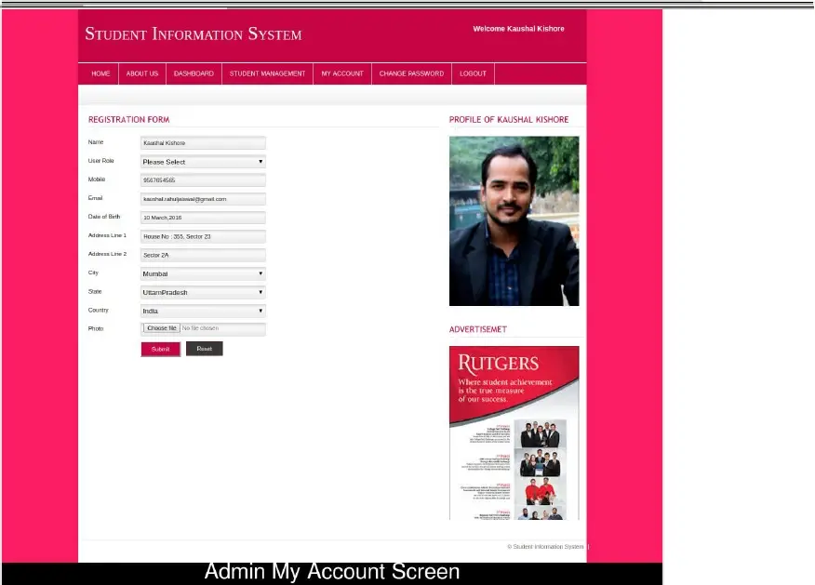

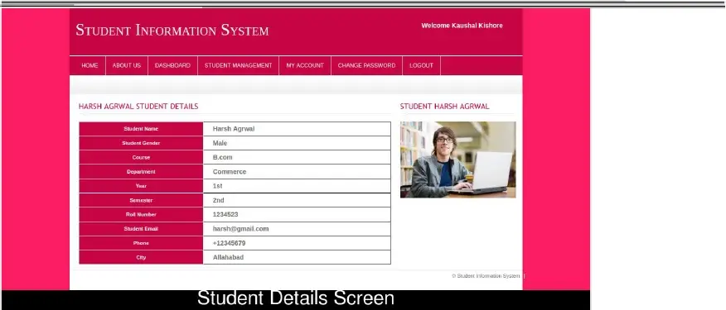

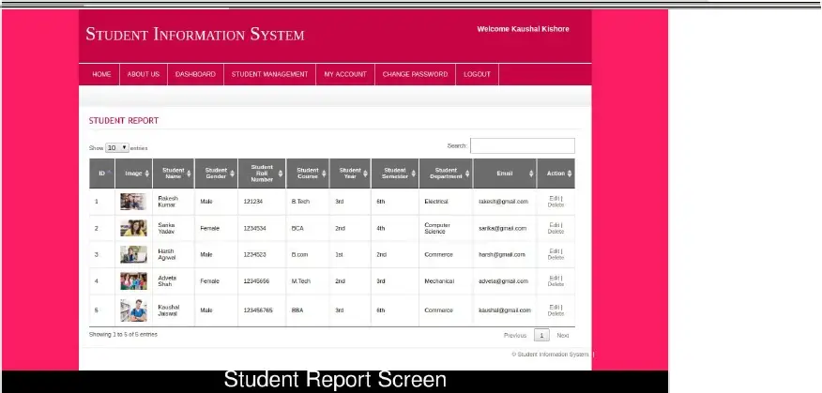

**CHAPTER 5**

**REFERENCES**

* www.google.com
* www.wikipedia.com
* www.w3schools.com
* www.studocu.com (Reference from Mr. Kapil Kaushik's Project Report) • www.freeprojectz.com (Reference from Project Report Student Information System)
* www.tutorialspoint.com
* www.javatpoint.com.